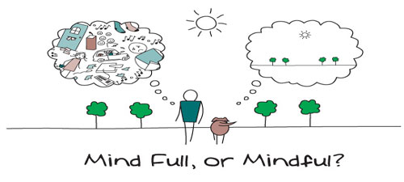
It is so important to make your de-cluttering project a practice in mindfulness. Observe each act of purging and organizing and be in it, not outside of it. Use it as a time to reflect and be “in the moment”. In this way, you honor the act and are more likely to return to the act routinely. – Diane Pruitt

One of my favorite phrases is “when in doubt, throw it out”. People who attach themselves to “things” have a hard time with this concept. But it serves you well when you want to rid your space and your life of clutter. There is an old expression that says “we must get rid of the old to make way for the new”. The very best way to tackle clutter is to start small - up to 20 minutes a day. Get rid of a few things using a shredder, trash bag, or donation bag. Work your way up to about 30 minutes a day, throwing out or donating as much as you can. Make it a habit and you will continue to manage your clutter long after your space is clear and clean.

The following are Di’s 10 Steps for Spatial Decluttering

1 Commit
Make a commitment to organizing yourself and your space – begin a 30-day program committing to making personal and organizational changes each day. Make it a mantra, a prayer, a meditation – whatever you do, make it routine.

2 Record
“White-board” your commitment – post it where you have to see it and be reminded of your commitment.
Commit to a minimum of 15-minutes a day. Commit to not adding any new clutter to what exists. “When in doubt, throw it out”. (If that suggestion causes heart palpitations, scan it and put it on disk.)

3 Dispose, Recycle, Donate
Make friends with your new tools – trash can, scissors, paper shredder, scanner and cd’s. Consider making a CD library of your paper files, emails and other media you can digitize.

4 A Place for Everything – Generate Storage Space When None Exists
If you have faced the problem of not having enough storage space, you know that everything can become a cluttered, disorganized mess. Storage space can be easily added through shelving, cabinet installation, drawers, storage units, bookcases and file cabinets, and of course, ridding yourself of unused items.

5 Everything in It’s Place – EVERY DAY
Absolutely no exceptions . . . if a thing has a place, put it back in it’s place when you are done with it. No exceptions.

6 Manage Your Postal Mail
It’s easy to let the mail pile up, but save yourself time in the long run and deal with incoming mail immediately. Sort your mail as soon as it arrives. Throw away junk mail, use organizers for mail that you handle once a week and mail you need to handle immediately.

7 Maintain an Efficient Filing System
Files that you do not use anymore, but may need in the future are best stored in file boxes. File boxes can be stored on shelves, in a closet or at an off-site storage center to save space. Know what you can throw away and what you need to keep. Throw away outdated information. Keep legal documents such as contracts, warranties and tax documents. Organize your files by color-coding, alphabetically, or by type of file. Consider having separate drawers for different areas of business, such as clients, finances, and media.

8 Maintain an Organized Computer
Keep your computer organized by creating folders, clearly naming files, saving files to appropriate folders, and creating shortcuts on your desktop. Shortcuts should be created for all Microsoft Office programs, the Internet, email, and your database.
9 If You Haven’t Read It, Used It, or Didn’t Remember it Existed after 2 years – Get Rid of It!
If it adds to your clutter, whatever it is, get rid of it. Either throw it out or donate it. If you haven’t used it for two years, you probably don’t need it and never did.

10 Restrict Purchases
If it adds to your clutter, whatever it is, don’t buy it. Get rid of the clutter first, then add what you need. Adding more stuff to your existing stuff does not resolve your clutter problem.

